CARL utilizes the sensing and automation techeologies available in the CASAS smart home architecture. The CASAS smart home project at Washington State University [3] deﬁnes a smart home environment as one that acquires and applies knowledge about its residents and their physical surroundings in order to improve their experience in that setting [1]. Such home environments, equipped with sensors for detecting features such as motion, light level, temperature, and energy and water consumption, are ideal testbeds for investigating the relationship between resident behavior and energy consumption and for providing activity-aware energy-eﬃcient home automation.

CARL系统利用了在CASAS智能家居架构中使用的传感和自动化技术。华盛顿州立大学[3]的CASAS智能家居项目定义了一个智能家居环境。该环境可以获取用户活动和住宅环境的知识，并运用获取到知识来提高用户体验[1].。该家庭环境部署有多种传感器，可以检测多种特征，例如：运动，光照等级，温度，能耗，水耗；因此，该环境是研究居民行为和能耗关系的理想实验平台。此外，该平台还可以为用户提供，基于活动感知的家庭能源自动化系统。

The CASAS “smart home in a box” software architecture components are shown in Figure 1. During perception, sensed information ﬂows up from the physical components through the middleware to the software applications. When taking an action, control moves down from the application layer to the physical components that automate the action. Each of the layers is lightweight, extensible and ready to use as is, without additional customization or training.

Firgure1描述了CASAS软件架构的组件。在感知阶段，传感信息从物理组件流出，经过中间件，传输到软件应用。在发起动作阶段，控制指令从软件应用层流到自动执行控制序列的物理组件。每一层都是轻量级，可扩展，并且易用的（不需要额外的定制或训练）。

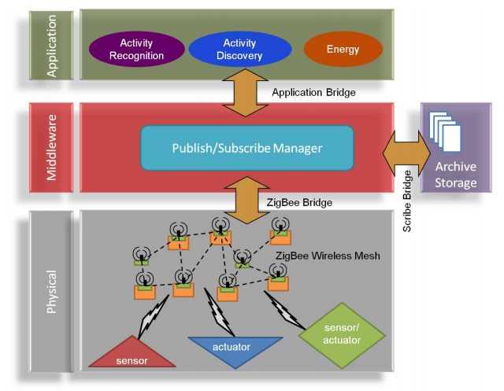

Figure 1: CASAS smart home components.

The CASAS physical layer contains hardware components including sensors and actuators, utilizing a ZigBee wireless mesh to communicate directly with the hardware components. The middleware layer is governed by a publish/subscribe manager, providing named broadcast channels that allow component bridges to publish and receive messages. In addition, the middleware provides valuable services including adding time stamps to events, assigning UUIDs, and maintaining site-wide sensor state model. Every component of the CASAS architecture communicates via a customized bridge to this manager over XMPP. Examples of such bridges are the ZigBee bridge, the Scribe bridge, which archives messages in permanent storage, and bridges for each of the software components in the application layer. To date, CASAS has installed over 40 smart home testbeds.

CASAS物理层主要含有利用ZigBee无线网进行个域网短距离通信的传感器和制动器。中间件层主要含有一个发布/订阅管理器；该管理器可以提供允许组件桥接模块发布和接收消息的命名广播通道。此外，中间件还可以提供如下有价值的服务：1）给事件加上时间戳，2）分配通用唯一识别码，3）维护站点范围内的传感器状态模型。每个CASAS架构中的组件，通过一个定制化的桥接模块，利用XMPP协议（可扩展通讯和表示协议）与中间件层中的管理器进行通讯。CASAS架构中的桥接模块主要有：1）ZigBee桥接模块，2）用来压缩消息并持久化存储的Scribe桥接模块，3）应用层软件组件之间的桥接模块。至今，CASAS已经部署在超过40个智能家庭实验平台。